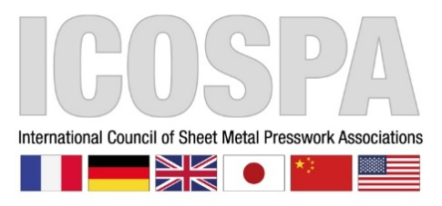

Thursday 20th October

ICOSPA Congress

National Metalforming Centre, 47 Birmingham Road, West Bromwich, B70 6PY, Satnav users to use the postcode, B70 6QE

If traveling by coach, pick up will be at 7.00 am 1st coach & 7.20 am 2nd coach - to leave outside the Grand Hotel at Colmore Row to CBM building

Congress

7.30 am - Registration & Breakfast
8.50 am - Sit down for Congress
9.00 am – Start of Congress
11.15 am – Tea & Coffee break
12.30 pm – Lunch & Exhibition
4.00 pm – Congress finish
4.15pm – The two coaches will depart the NMC back to Colmore Row, Birmingham

Please advise of any dietary requirements.

